# Example Data

**Location:** **Copy-Word-tables-to-Excel-main/2. Example Data**

You can find the example word report that contains 2 two tables to be extracted to excel. The excel files are the templates & results in next sections.

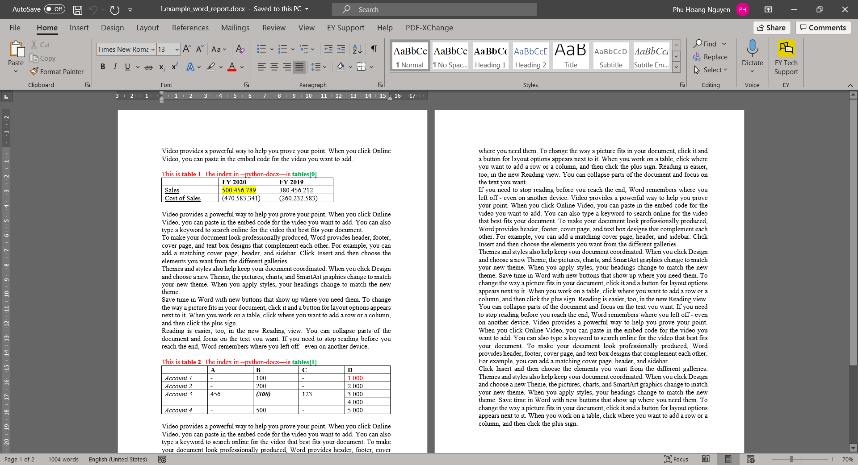

*Example Word Report*

# Copy tables with no template

**Key actions:**

* Create a blank Excel file (only 1 sheet)

This option will create a blank excel file, but the file will only have 1 sheet. All tables from the word file would be copy into this sheet. Each tables would be separated by 3 blank lines in excel.

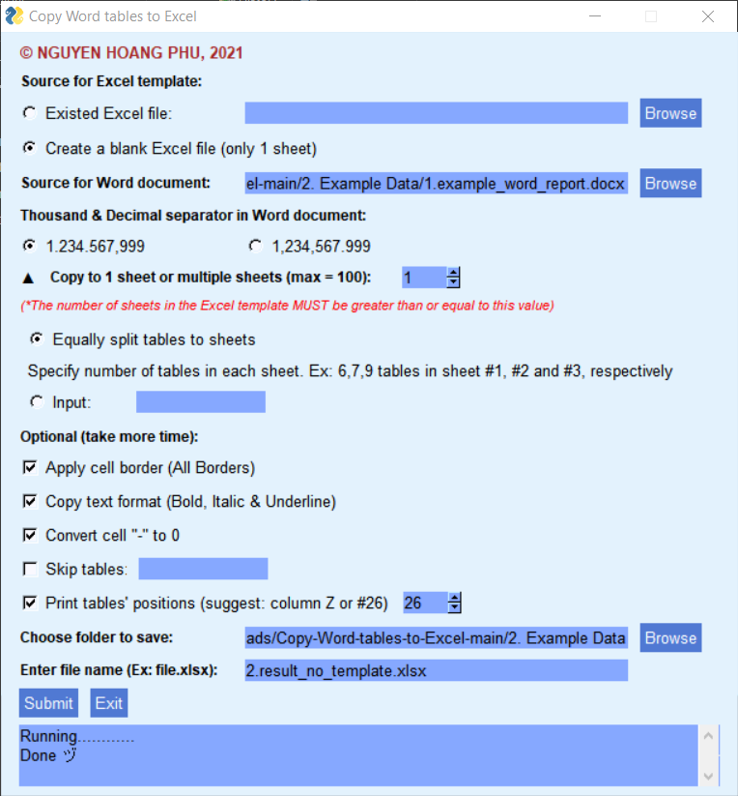

*Options for no template*

**Result:**

* The merged cells in the word report would be treated as 2 lines when copy to Excel.
* The tables’ positions are printed in column Z (#26) in excel. This index would help when using the Skip and Split options.

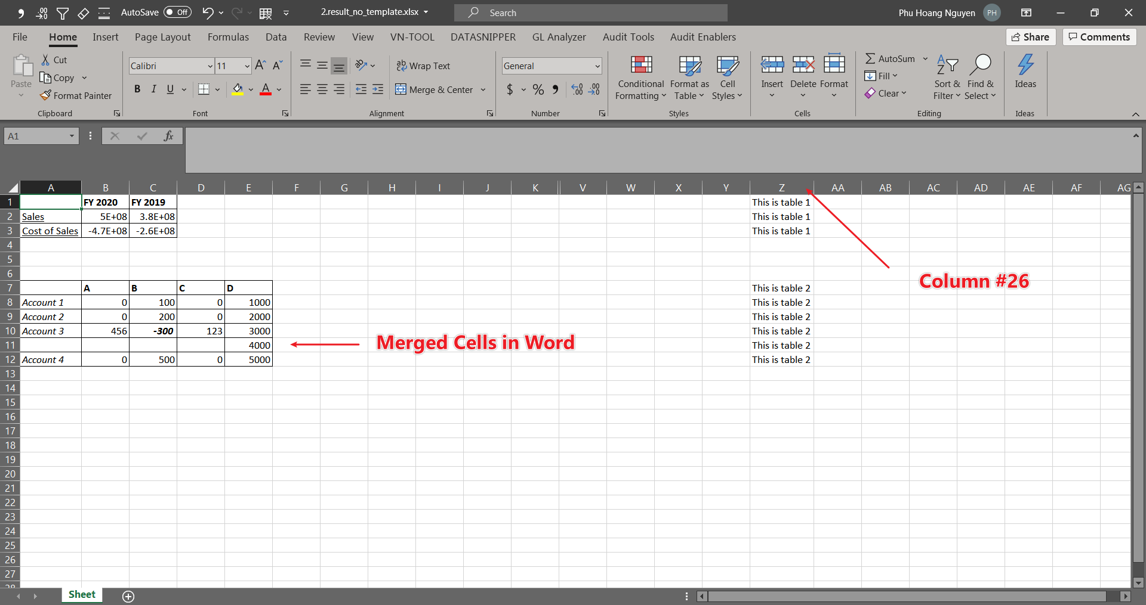

*Result without template*

# Copy tables with template

**Template:**

* Sometimes you may want to calculate with the data in tables, and the word report might have to be updated frequently. You might want to create a template with formulas and when the data updated, you only need to copy the data and the formulas would calculate with updated data.
* I created **3.1.template.xlsx** to calculate Profit in table 1 and Total in table 2. The data in the template is example to understand the formulas.

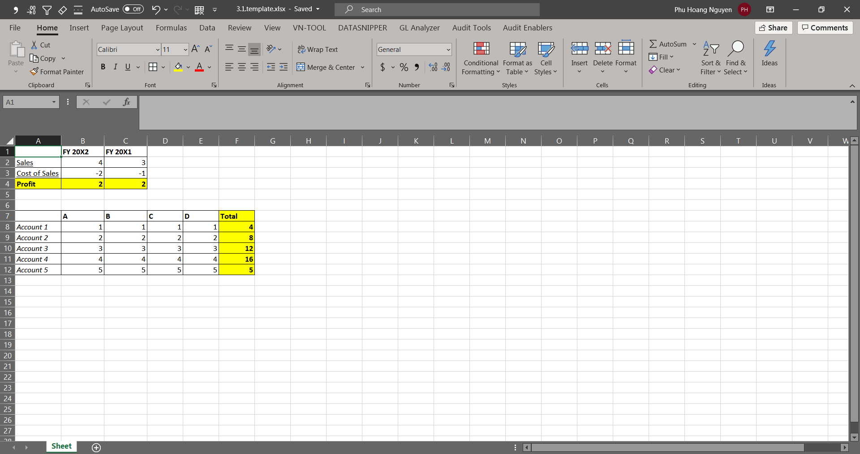*Excel template – formulas*

**Key actions:**

* Existed Excel file

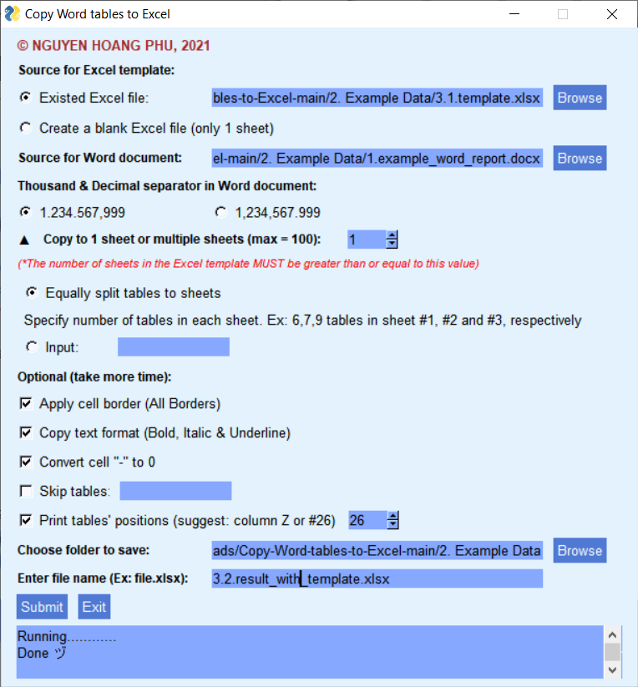

*Options for template*

**Result:**

* The data from the word report is copy to the template and the formulas in excel also calculate with updated data.
* Do note that there would be 3 blank lines between 2 consecutive tables. This option is hard-coded and can be only changed when you edit my source code and create new .exe version. Therefore, you should keep this in mind when you want to create formulas near the tables to avoid the data would be overwrited in the formula cells.

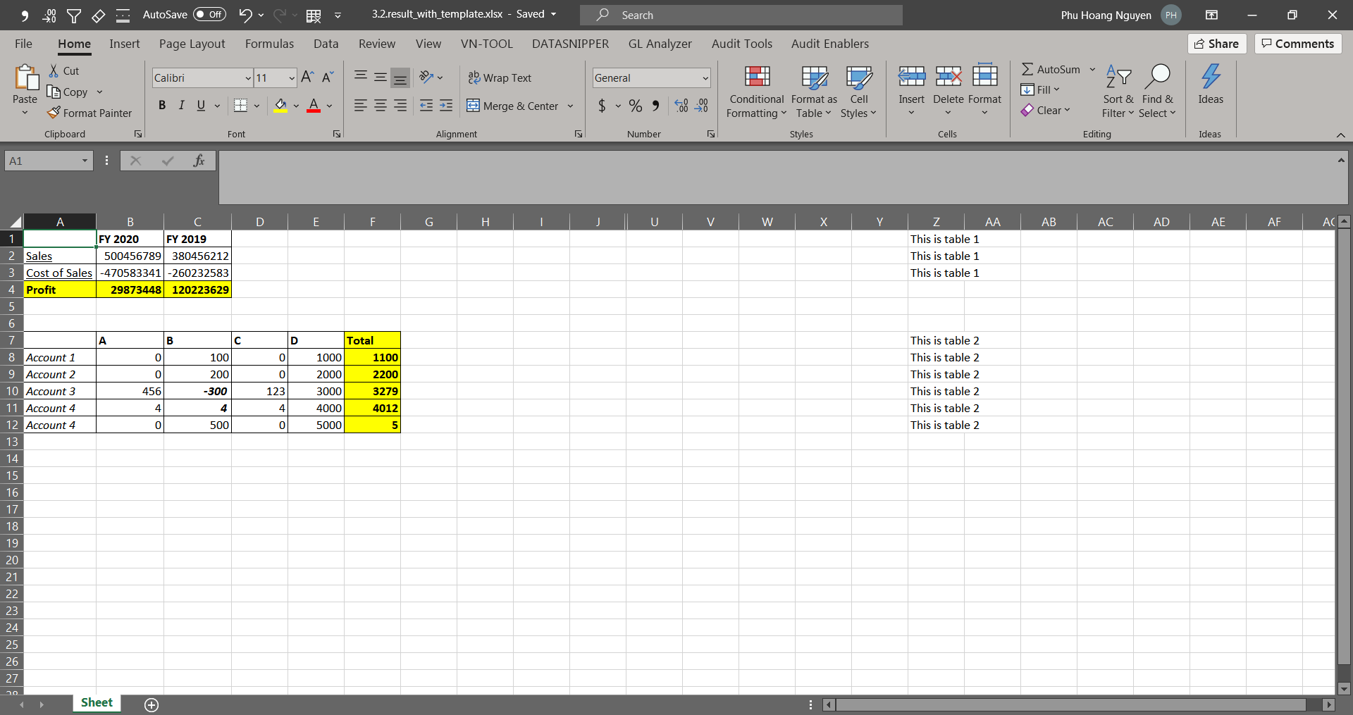

*Result with template*

# Copy tables to multiple sheets

**Template:**

* When you want to splits your tables from word into multiple sheets, you should create a excel file with the number of sheets that you want. This excel file would be used as template.
* I created **4.1.blank_template_with_2_sheets.xlsx** to use as template to split 2 tables into these sheets.

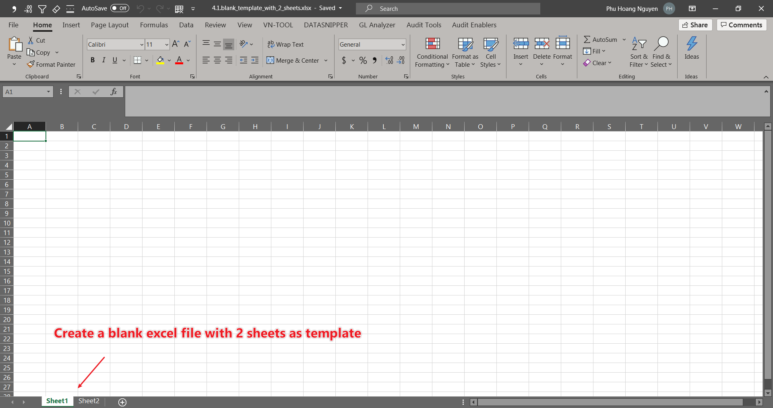

*Excel template – 2 sheets*

**Key actions:**

* Copy to 1 sheet or multiple sheets (max = 100)
* Input

Click the ▼▲ icons to toggle display options “Equally split tables to sheets” (default) & “Input”

The equally split is straightforward. For example: if you split 10 tables into 5 sheets, each sheet would contain 2 tables. But if you split 10 tables into 3 sheets, it would split by 4/4/2.

Input: you should input the number of tables for each sheet. And the total of the input must equal the total tables of the word reports. For the example in the image: 22 tables splitted into 3 sheets by 6/7/9 tables.

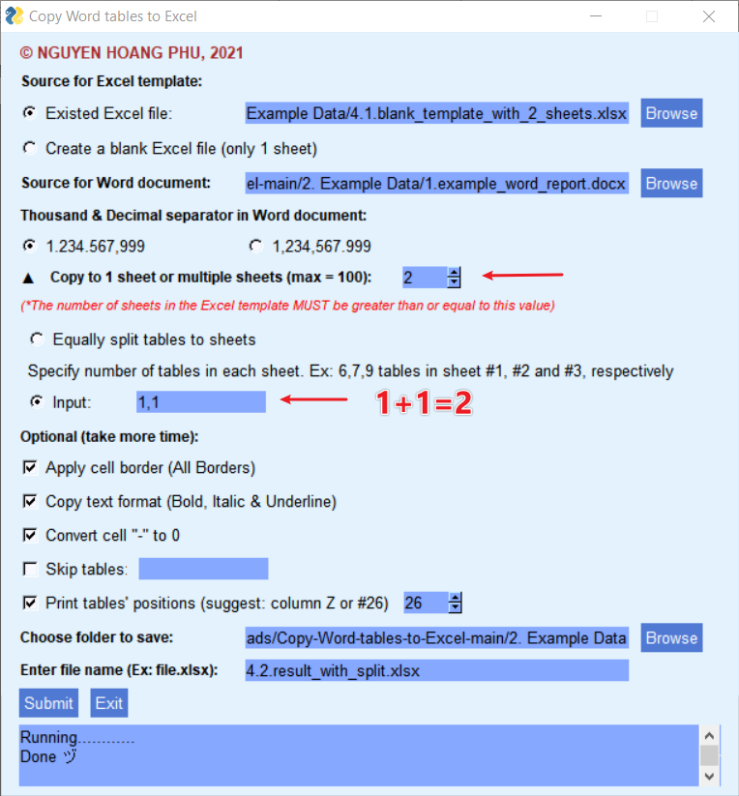

*Options for split tables*

**Result:**

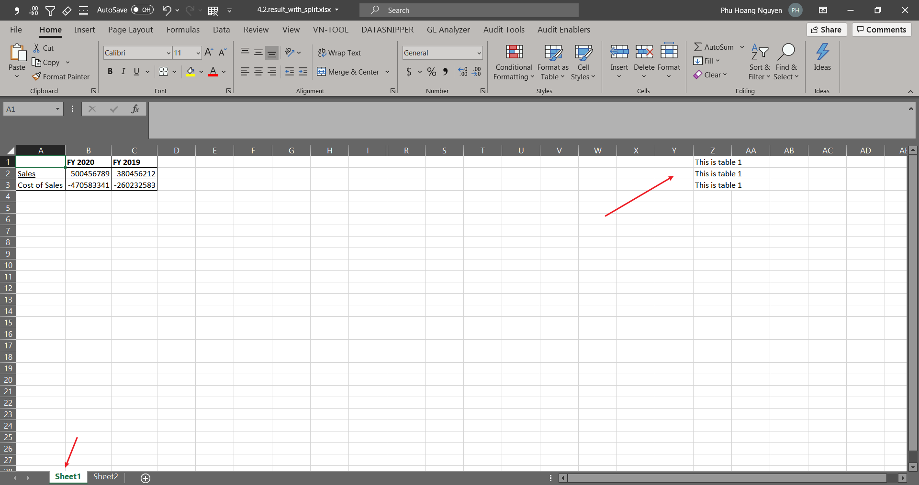

*Result with split – sheet 1*

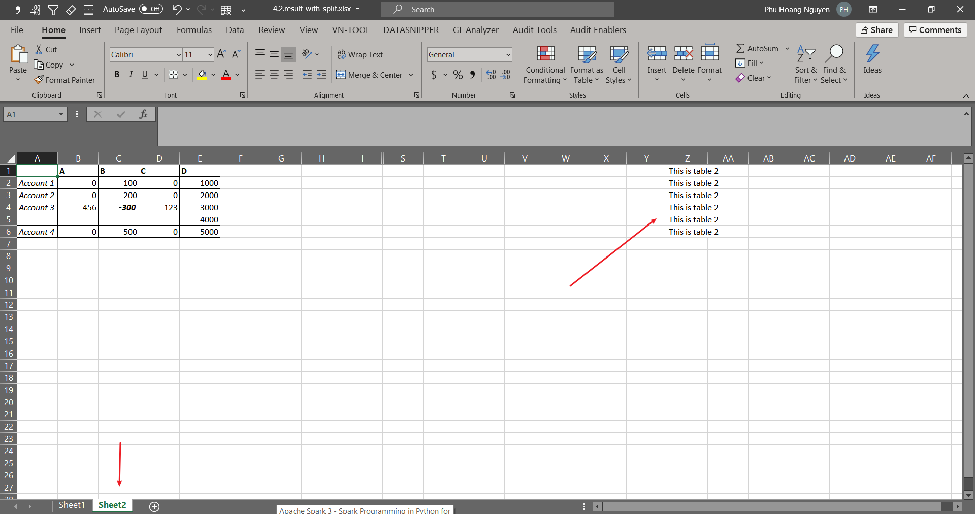

*Result with split – sheet 2*

**Tip:**

You should copy without template into a draft excel file, then decide how many tables would be splitted into each sheet in case you don’t want to equally split.

# Copy tables with “skip tables” option

**Key actions:**

* Skip tables

This option is straightforward. You want to skip some irrelevant tables from the word report. Because this tool would copy all tables that it recognizes in the word report, some of those tables may be created for “formatting” purposes only and you don’t want to copy it to excel.

In this example I skip the 1st table in the word report. The index to be inputted in the skip tables would be “1” (when skip multiple tables, separate the tables’ index by comma).

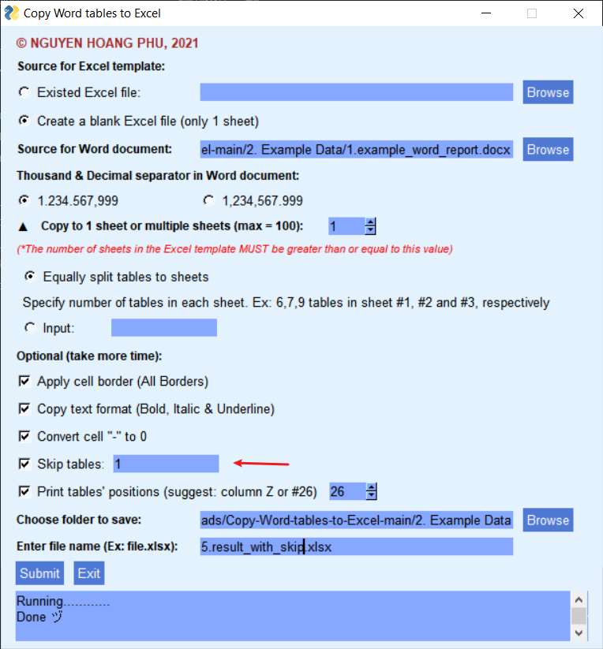

*Options for skip tables*

**Result:**

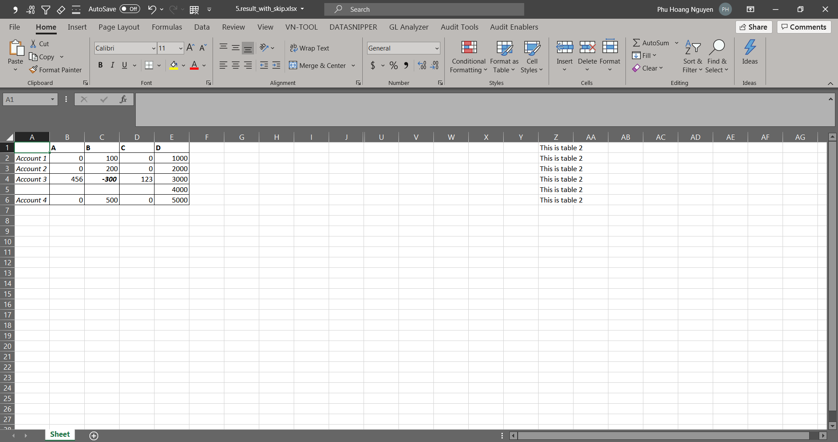

*Result skip tables*

**Tip:**

You should copy without template into a draft excel file with option “Print tables’ positions”, then decide which tables to be skipped.

# v1.2.0 update

* Theme color change
* New function: Save check point (recommended). This function is used to store the logging txt files. The logging file will be appended for multiple runs per each start of application *(image below)*. Meaning that if you want to create separate logs for separate runs, you need to close the application and restart.
* The location of the log file is in the parent directory of the application. For example:
  + The location of the application is:

/path/parent/apps/wordToExcel-v1.2.0.exe

* + The location of the log file would be:

/path/parent/wordToExcel_logs/log_yyyy_mm_dd_hhmmss_.log

